stpilogon

**STP Unit Renewal application**

**General Instructions:**

**Step1:** Fill about Company, Promoter, Capital, Investment, Project Exports, Collaboration, FE details, Manpower and other details.

**Step2:** Upload all mandatory documents.

**Step3:** Download application form and Sign it. Upload scanned copy of Renewal Application Form.

1. **Click on LOP/LUT--> Renewal of Lop from side bar menu**

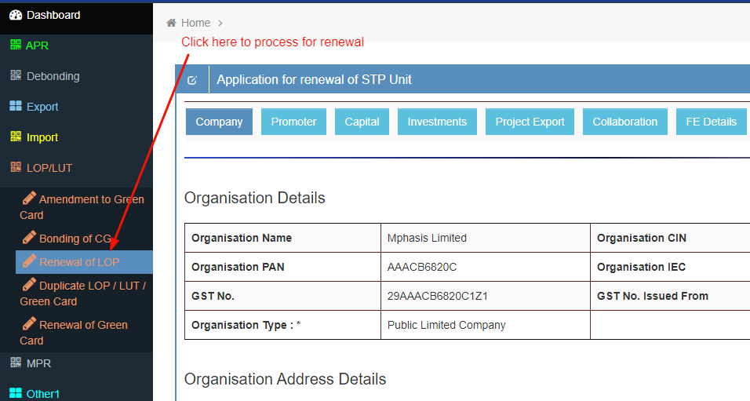

1. 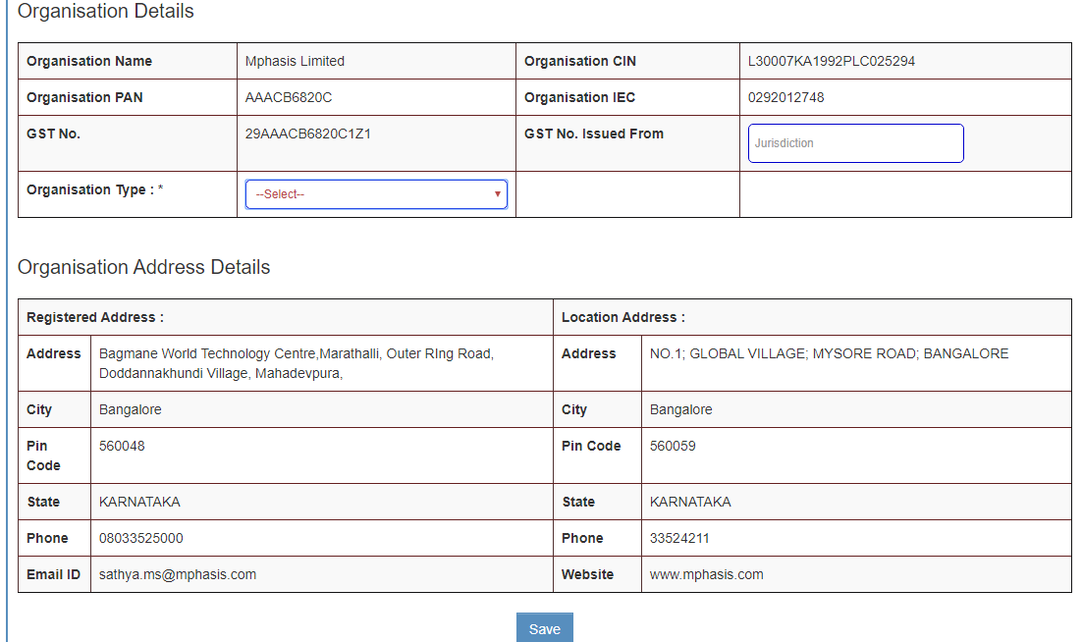**Enter Company details and click on Save button.**
2. **Click on Promoter Menu , Enter Promoter details and click on save button.**

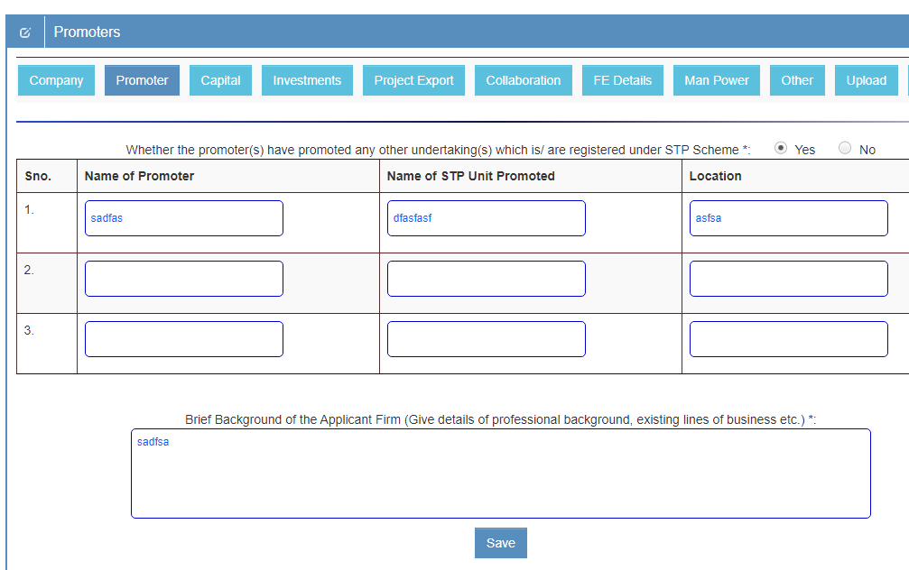

1. **Click on capital menu. (If company is Private Limited/Public Limited). Enter all details and click on save button**

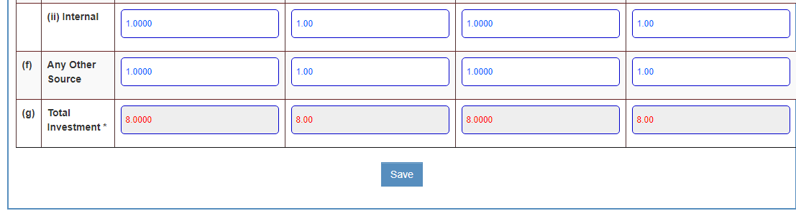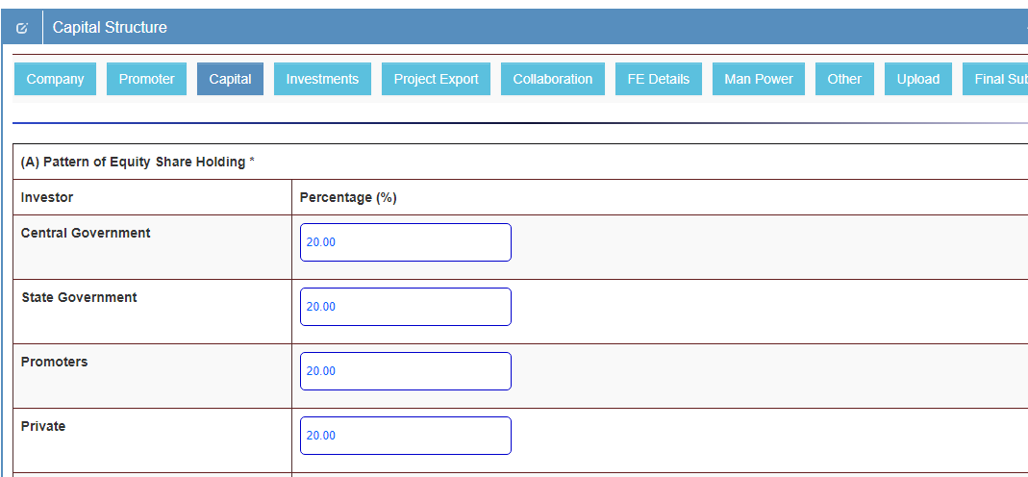

1. **Click on investments menu, Enter existing and proposed value then click on save button**

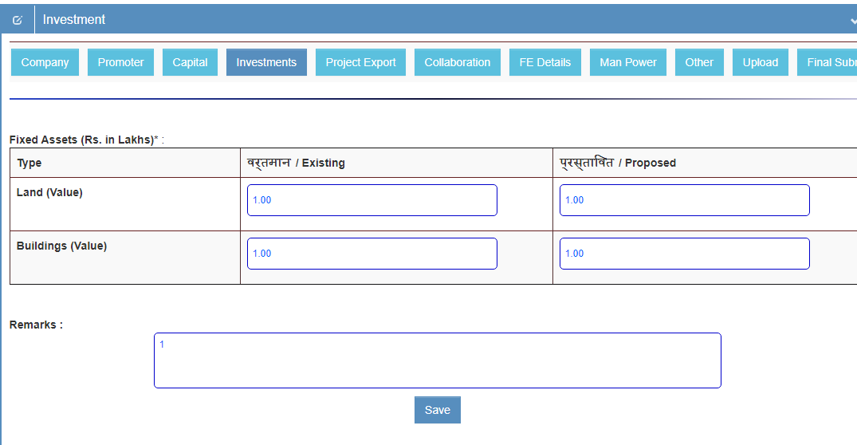

1. **Click on project export menu , Enter all details and click on save button.**

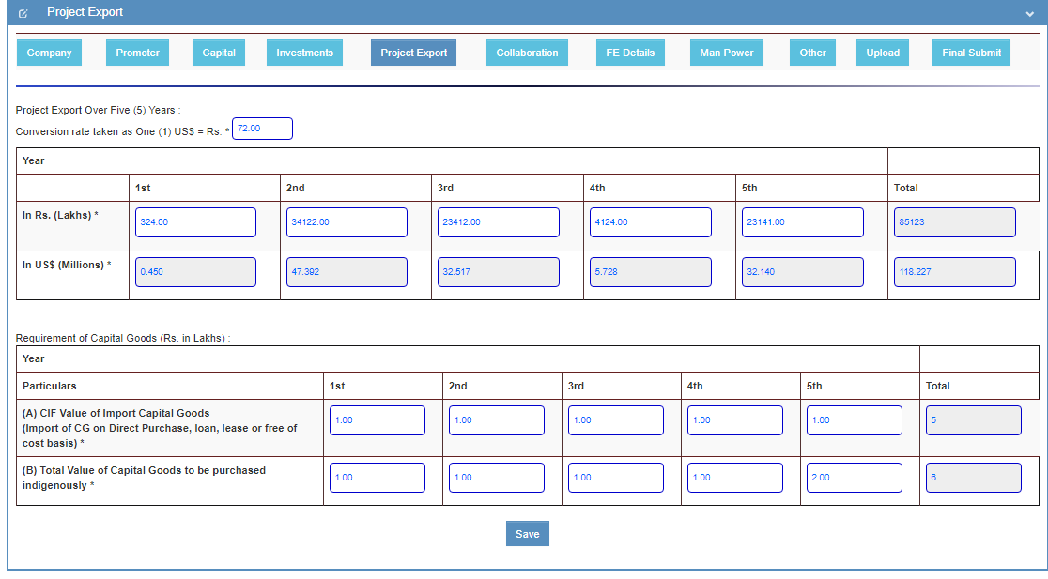

1. **Click on Collaboration menu, Enter all details and click on save button**

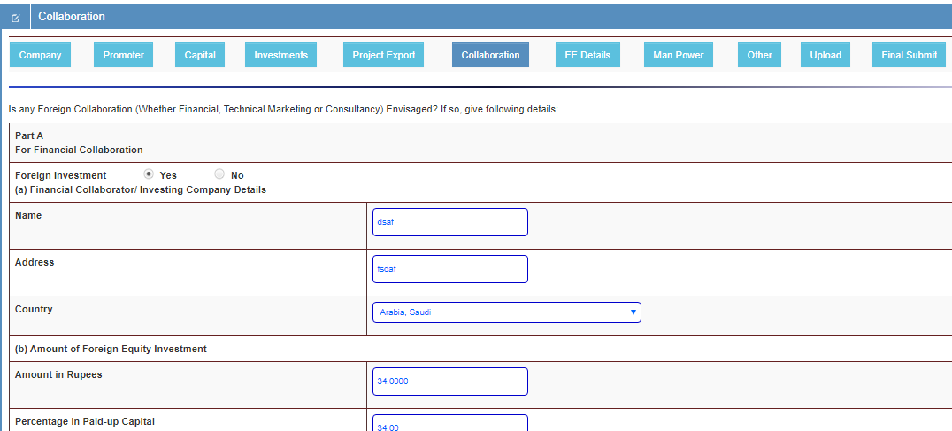

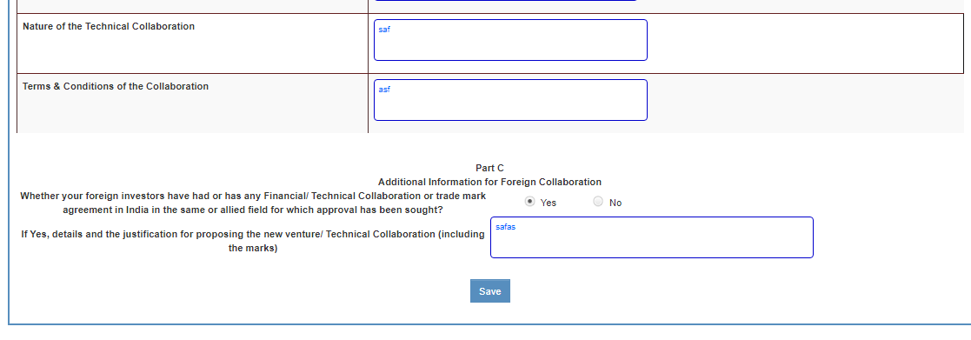

1. **Click on FE Details menu, Enter Foreign Exchange value and click on save button**

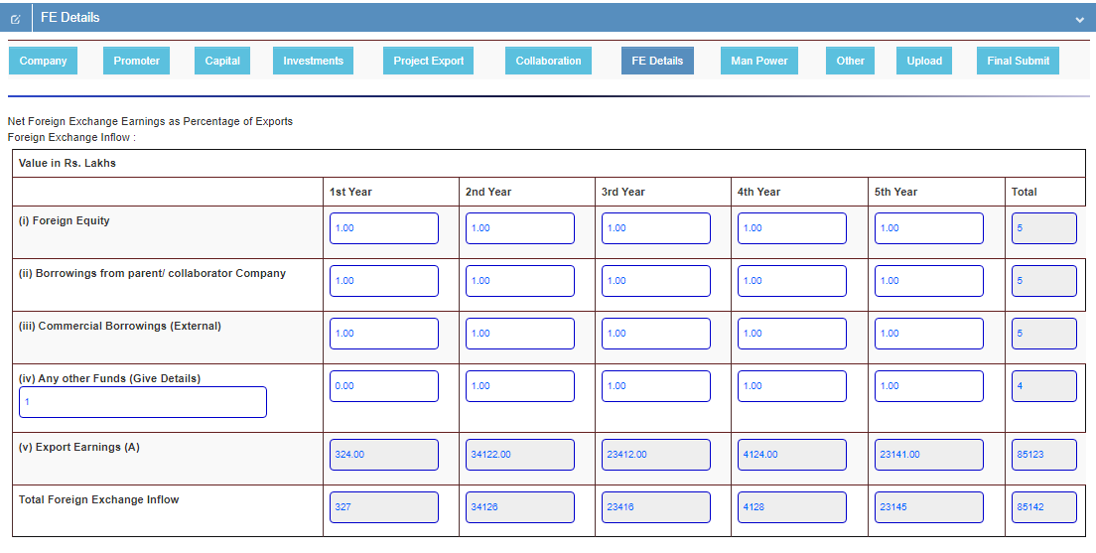

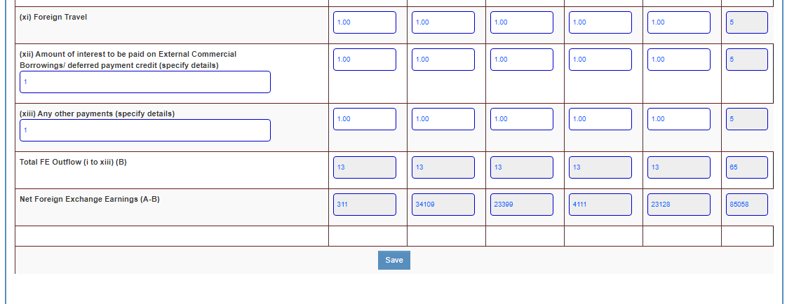

1. **Click on Man power details menu, Enter existing and proposed manpower details and click on save button**

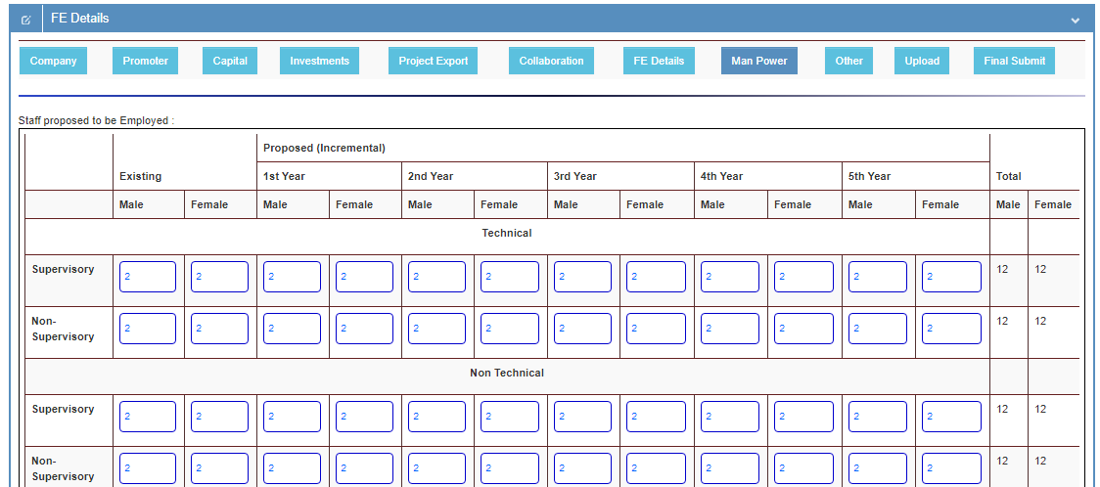

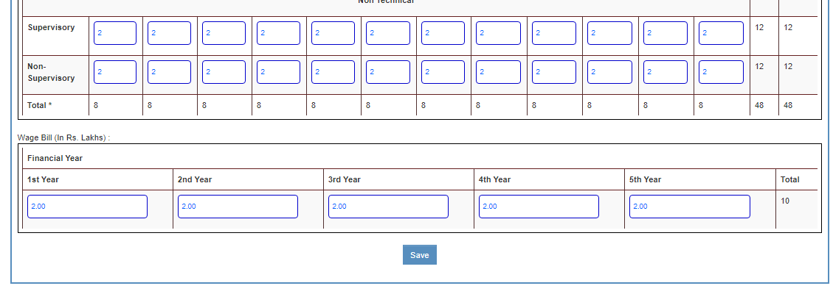

1. **Click on other menu, Enter Other requirement details and click on save button**

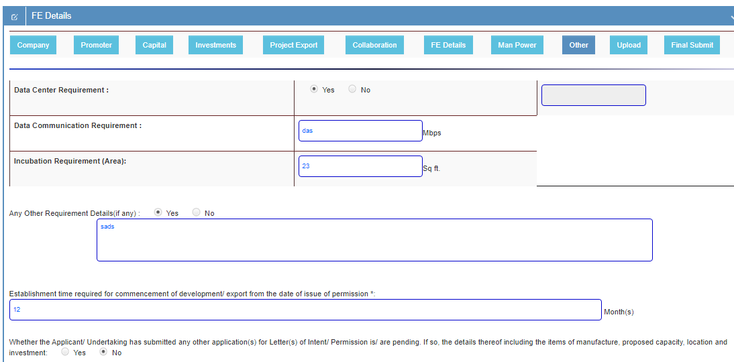

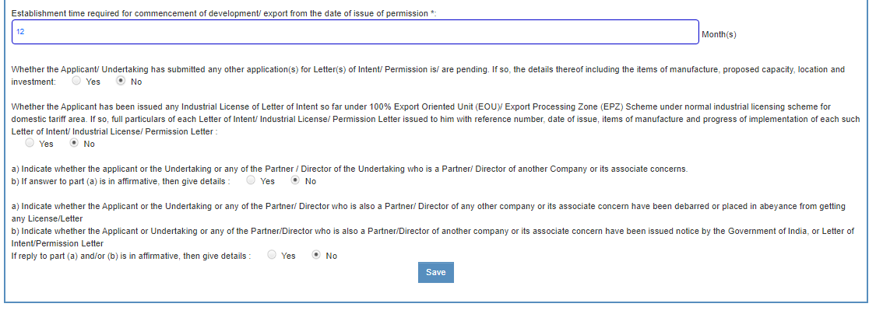

1. **Click on upload menu, Select .pdf file of require documents and upload one by one**

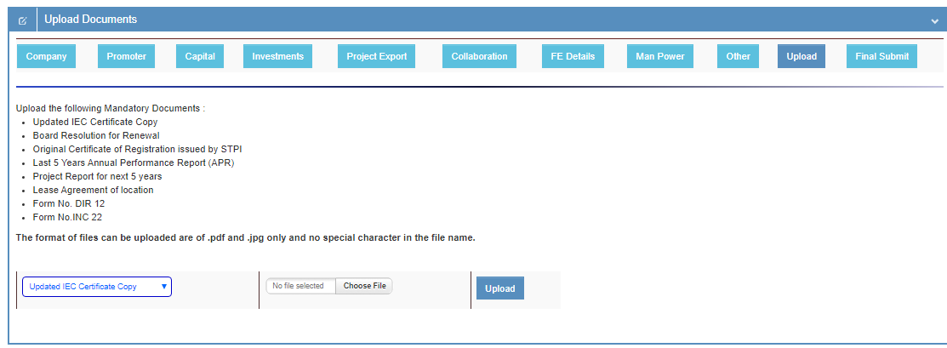

1. **Click on final submit menu, click on download application form button.**

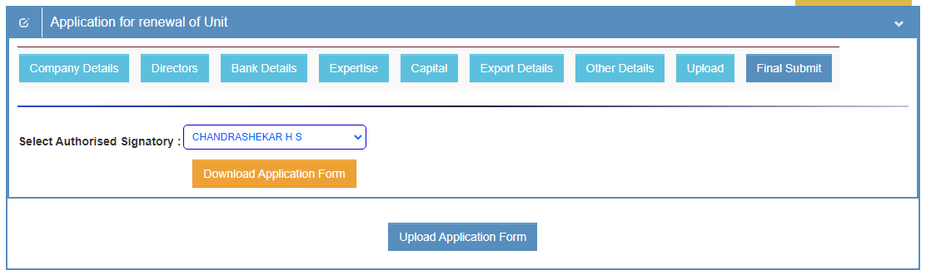

1. **After download application form signature & seal on each page then click on upload button.**

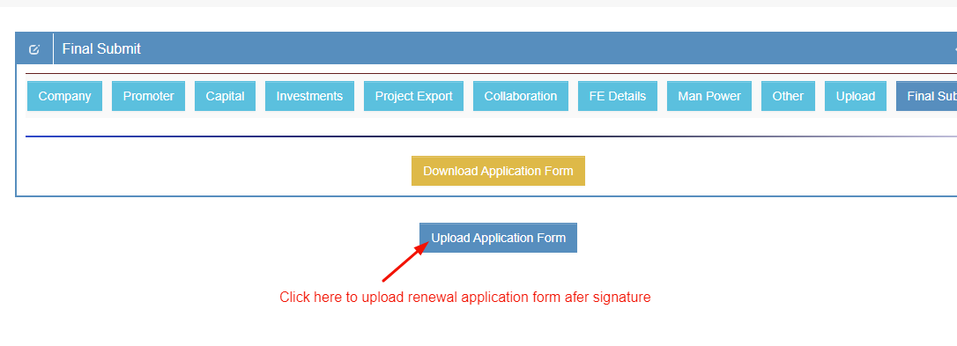

1. **Upload singed application form (.pdf ) type , click on final submit button.**

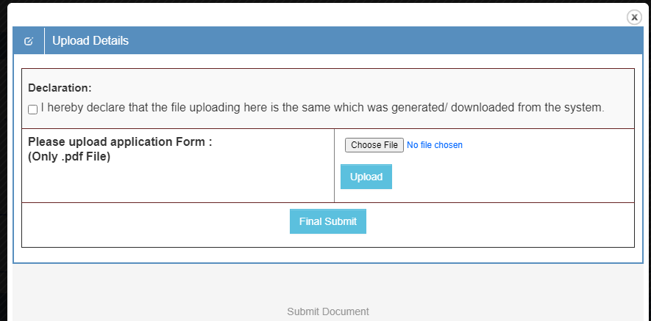

1. **Now status is showing Pending.**

